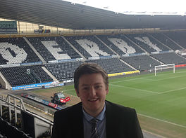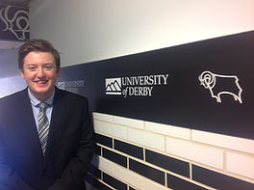

**Max adams**

**Placement Timetable 2015-16**

**Derby County Football Club, Willmott Dixon, Drayton Manor**

|  |  |  |  |
| --- | --- | --- | --- |
| **Placement Type** | **Date** | **Times** | **Location** |
| Scarf Giveaway DCFC (Vs Wolves) | 18th October 2015 | 9am- 1pm | iPro Stadium – Fan Areas |
| Community DCFC | 4th November | 10am – 5pm | iPro Stadium – Community Office |
| Commercial Department DCFC (Vs Cardiff) | 19th – 21st November | 19th - 1pm-5pm 20th - 9am-5pm 21st - 10am- 6pm | iPro Stadium – Main Offices / Toyota Lounge |
| Marketing Department DCFC | 4th March | 10am-5pm | iPro Stadium – Main Offices |
| Drayton Manor Family Day DCFC (Vs Huddersfield) | 5th March | 12pm-3pm | iPro Stadium – East Stand |
| Willmott Dixon Coaching Project | January 2016 – May 2016 | Preparation ongoing -  Coaching Sessions (April/May) 7pm-8pm | University of Derby Sports Centre |
| Media DCFC | 16th March | 10am – 5pm | iPro Stadium – Main Offices |